Chapter 2: Why is Cape Town experiencing shortages in water?

Weather and climate context in South Africa
Based on results of AR5 GCM and sea level change projections.
Drought was one in 311 year event (link)
1. Climate zones
- Diverse climate largely influenced by variations in elevation; humid regions influenced by Indian Ocean in south-east are where sub-tropical climate is. Cape region (i.e. around Cape Town), Mediterranean climate conditions occur. Inland exists semi-arid and arid climates.¹⁰
2. Temperature
- Temperatures up to and over 32 in summer months and can be below zero in winter months at higher elevations in winter.¹⁰
- Cape Town annual mean temperature 16.1C.¹⁰
- Cold Benguela current along west coast keeps it slightly cooler than east coast (difference of about 5C).¹⁰
- Mean annual temperature has been increasing at 0.14C per decade over the last 30 years.¹⁰
- End-of-century warming in range of 1.7 to 4.7C compared to 1971-2000 reference period.¹⁰
3. Precipitation
- Freshwater supply under risk from relatively small changes in precipitation. 10% drop in precipitation for Cape Town predicted to cut perennial surface water supply by over 20% (link)
- South Africa experiences rainy season from convective rainfall in summer months (mid-October to mid-February).¹⁰
- Southwest region, including Cape Town, obtains mid-latitude frontal precipitation during winter.
- No substantial change in precipitation observed over past 113 years of data.¹⁰
- Predicted weak likely range of change in annual total precipitation from -9 to 0 % by 2018 with medium confidence.¹⁰
- Low scenario gives median change of -3% by 2085, high scenario -7%.¹⁰
- Below 2C target is -11 to +2% with above 4C threshold at -17 to -1%.¹⁰
4. Drought
- Weak change in duration of long-lasting dry spells increasing by +1 to +3 days by 2085 with a medium confidence.¹⁰
- Low scenario gives median change of +1 day by 2085, high scenario +3 days.¹⁰
- Below 2C target is 0 to 3 days with above 4C threshold at -+1 to +6 days¹⁰
5. Water balance
- Medium-strong change with likely range from -46 to +14mm/yr by 2085 at low confidence.
- Below 2C target is -33 to +32mm/yr with above 4C threshold at -71 to +38mm/yr.¹⁰
6. Sea-level rise
- Sea rise by end of century by Cape Town in range of +0.44-+0.98m. ¹⁰
7. Threats to water supply under climate change
- Change in annual precipitation by 2100 in range of -9 to 0% (compared with 1971- 2000).¹⁰
- Projections also suggest more intense rainfall events followed by prolonged duration of dry spells. No clear trend on frequency of heavy rainfall events.¹⁰

Informal settlement upgrades
- ‘Since late 1980s, when the Apartheid pass-law system was disbanded, … urbanisation… has radically transformed South African cities.’ (link)
- Creation of informal settlements of working poor on edges of urban landscape.
- Background of formal process to upgrade informal settlements (link)
- Map of Cape Town informal settlements and possibility of upgrade (link).
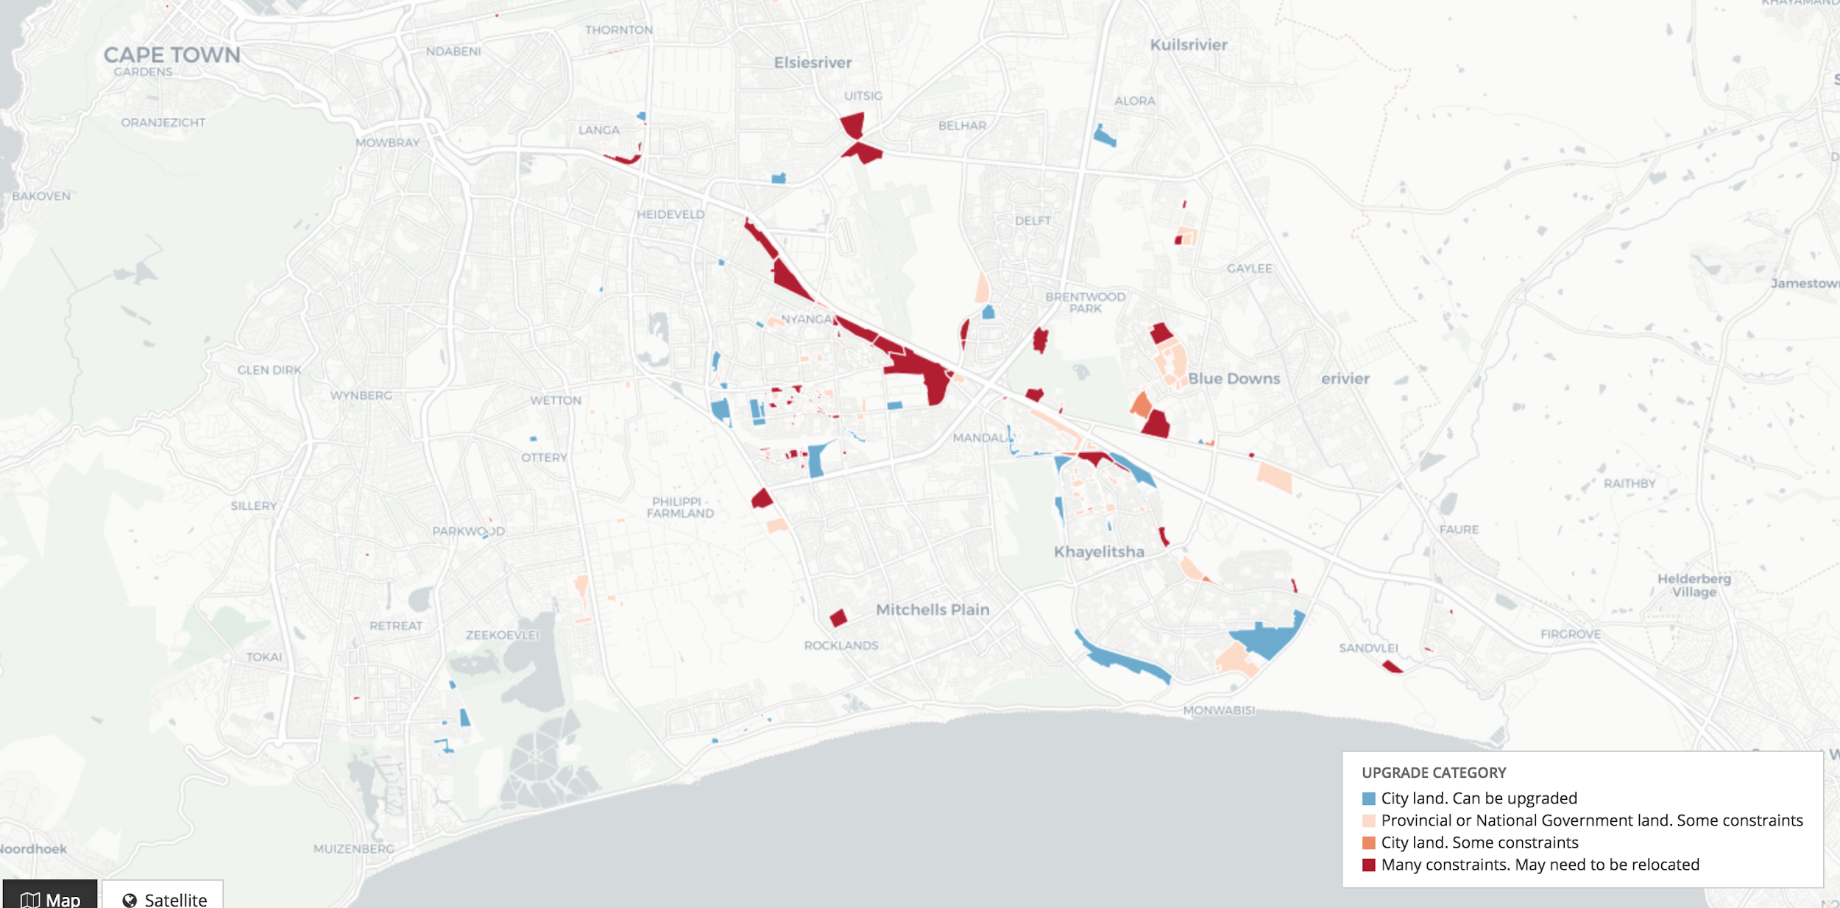
- With the end of Apartheid, also guarantee in constitution (see above) for water supply. (link)
- When comparing 2001 census with 2011 census, progress in access to piped (tap) water (link):

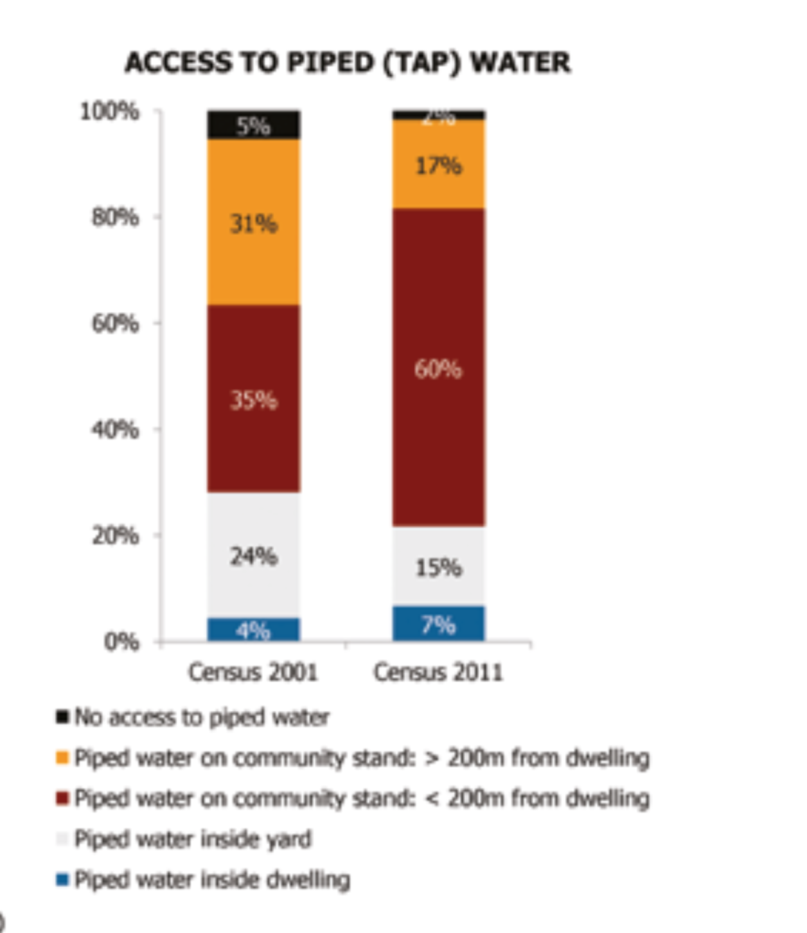

Increase in population relative to water storage increase:
- Source of graphs below (link):
- I.e. water supply per capita is decreasing steadily since the introduction of extra capacity via the Theewaterskloof Dam in 1980:
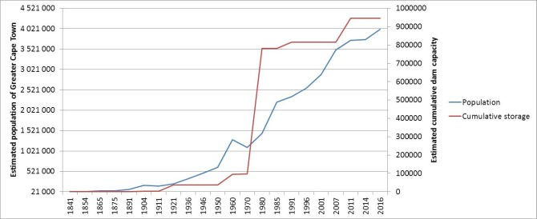
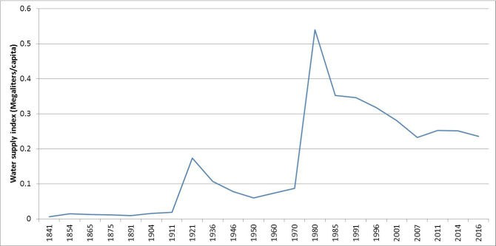

What is ‘Day Zero’ and what happens?
1. How was Day Zero defined?
- Defined by City of Cape Town as when dam levels falling below 13.5% of total capacity. (link)
- Point at which Disaster Risk Management Centre introduces phase 2 of its plan.
- Phase 2 is a ‘desperate bid’ to avoid Phase 3, where there is no more surface water supply. At that point, bottled water from
- Not a fixed day. Has moved from April 12 to July 9 and in fact was never reached in the end. (link)
- Full-Scale Emergency Stage 3 was for months, from 3-6 months.
2. What would have happened from Day Zero?
- Residents will have to stand in line to collect 25 litres of water per person per day (link), in line with WHO recommendations.
- Most taps will have turned off, leaving only vital services with access to water.
- Informal settlements with majority of densely populated informal settlements will remain linked
- Schools will close, along with most businesses, unless they possess their own bore holes and temporary off-mains toilets and drinking water.
- Alternative sources groundwater, desalination explored.
- Level 6B water restrictions was 450 million litres per day, or 50 litres per person occurred by Feb 1st 2018.

